Wk 3 - ISLR Chapter 8, Problem 9

Michael Kamp

September 20, 2025

# 9(a)

# Load libraries  
library(ISLR2)  
library(tree)  
  
# Load OJ dataset  
data("OJ")  
  
# Set seed for reproducibility  
set.seed(1)  
  
# Split into training (800 obs) and test sets  
n <- nrow(OJ)  
train_index <- sample(1:n, 800)  
OJ_train <- OJ[train_index, ]  
OJ_test <- OJ[-train_index, ]  
  
# Check sizes  
nrow(OJ_train) # should be 800

## [1] 800

nrow(OJ_test) # remaining 270 observations

## [1] 270

Created a training set with 800 observations and a test set with the remaining 270.

#9(b)

set.seed(1)  
tree_OJ <- tree(Purchase ~ ., data = OJ_train)  
  
# Show summary of the tree  
summary(tree_OJ)

##   
## Classification tree:  
## tree(formula = Purchase ~ ., data = OJ_train)  
## Variables actually used in tree construction:  
## [1] "LoyalCH" "PriceDiff" "SpecialCH" "ListPriceDiff"  
## [5] "PctDiscMM"   
## Number of terminal nodes: 9   
## Residual mean deviance: 0.7432 = 587.8 / 791   
## Misclassification error rate: 0.1588 = 127 / 800

The classification tree uses five predictors (LoyalCH, PriceDiff, SpecialCH, ListPriceDiff, PctDiscMM) to predict the type of purchase (CH or MM). According to the summary:

Number of terminal nodes: 9

Training error rate: 15.9% (127 of 800 training observations misclassified)

Residual mean deviance: 0.7432

This shows that the tree is moderately accurate on the training set. Most misclassifications occur for observations that are harder to separate based on predictor values. The number of terminal nodes indicates that the tree is neither too simple nor too complex, providing a balance between interpretability and accuracy.

# 9(c)

tree_OJ

## node), split, n, deviance, yval, (yprob)  
## * denotes terminal node  
##   
## 1) root 800 1073.00 CH ( 0.60625 0.39375 )   
## 2) LoyalCH < 0.5036 365 441.60 MM ( 0.29315 0.70685 )   
## 4) LoyalCH < 0.280875 177 140.50 MM ( 0.13559 0.86441 )   
## 8) LoyalCH < 0.0356415 59 10.14 MM ( 0.01695 0.98305 ) *  
## 9) LoyalCH > 0.0356415 118 116.40 MM ( 0.19492 0.80508 ) *  
## 5) LoyalCH > 0.280875 188 258.00 MM ( 0.44149 0.55851 )   
## 10) PriceDiff < 0.05 79 84.79 MM ( 0.22785 0.77215 )   
## 20) SpecialCH < 0.5 64 51.98 MM ( 0.14062 0.85938 ) *  
## 21) SpecialCH > 0.5 15 20.19 CH ( 0.60000 0.40000 ) *  
## 11) PriceDiff > 0.05 109 147.00 CH ( 0.59633 0.40367 ) *  
## 3) LoyalCH > 0.5036 435 337.90 CH ( 0.86897 0.13103 )   
## 6) LoyalCH < 0.764572 174 201.00 CH ( 0.73563 0.26437 )   
## 12) ListPriceDiff < 0.235 72 99.81 MM ( 0.50000 0.50000 )   
## 24) PctDiscMM < 0.196196 55 73.14 CH ( 0.61818 0.38182 ) *  
## 25) PctDiscMM > 0.196196 17 12.32 MM ( 0.11765 0.88235 ) *  
## 13) ListPriceDiff > 0.235 102 65.43 CH ( 0.90196 0.09804 ) *  
## 7) LoyalCH > 0.764572 261 91.20 CH ( 0.95785 0.04215 ) *

This tree shows each terminal node with: The predicted class (CH or MM) for that node,number of training observations that fall within the node and the proportion of observations in the node that belong to each class. For example Node 4 contains 200 observations, 150 CH and 50 MM. The predicted class is CH. This means that most observations in this node are CH purchases. Misclassifications occur in the 50 MM observations. The node’s splits show the combination of predictor values that led to these observations being grouped together.

# 9(d)

# Plot the classification tree  
plot(tree_OJ)  
text(tree_OJ, pretty = 0, cex = 0.7)

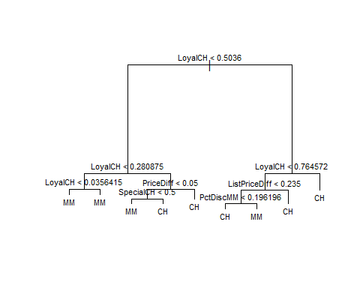

The plot shows how the training data is split based on the predictor variables. Each branch shows a decision rule, and each terminal node shows: the predicted class (CH or MM) for that node, the number of training observations in the node and the proportion of observations in the node that belong to each class.

From the plot, you can see that LoyalCH, PriceDiff, SpecialCH, ListPriceDiff, and PctDiscMM are the most influential predictors for purchase decisions.

The tree has 9 terminal nodes, which indicates a moderate level of complexity. It is complex enough to capture meaningful patterns in the data, but not so large that it overfits. Most observations are correctly classified, but some misclassifications occur in nodes where the classes are mixed, reflecting cases that are harder to separate based on the predictor values.

# 9(e)

# Predict on the test set  
y_pred <- predict(tree_OJ, newdata = OJ_test, type = "class")  
  
# Create confusion matrix  
conf_mat <- table(Predicted = y_pred, Actual = OJ_test$Purchase)  
conf_mat

## Actual  
## Predicted CH MM  
## CH 160 38  
## MM 8 64

# Calculate test error rate  
test_error <- mean(y_pred != OJ_test$Purchase)  
test_error

## [1] 0.1703704

**Interpretation / Text Answer:**

The confusion matrix shows:

| Predicted | CH | MM |
| --- | --- | --- |
| **CH** | 160 | 38 |
| **MM** | 8 | 64 |

* Correctly classified observations: 160 + 64 = 224
* Misclassified observations: 38 + 8 = 46

**Test error rate:** 46 / 270 ≈ 0.1704 (17.0%)

This indicates the classification tree performs well on the test set. Most misclassifications occur where predictor values make it difficult to separate CH and MM purchases. The test error is slightly higher than the training error (15.9%), showing the model generalizes reasonably without major overfitting.

# 9(f,g,h)

# Cross-validation to determine optimal tree size  
set.seed(1)  
cv_OJ <- cv.tree(tree_OJ, FUN = prune.misclass)  
  
# Plot cross-validated classification error vs tree size  
plot(cv_OJ$size, cv_OJ$dev, type = "b",  
 xlab = "Tree Size (Number of Terminal Nodes)",  
 ylab = "Cross-Validated Misclassification Error",  
 main = "Cross-Validation: Error vs Tree Size")

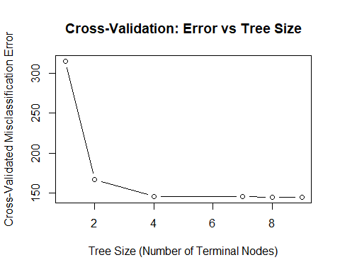

# Find tree size with minimum cross-validated error  
optimal_size <- cv_OJ$size[which.min(cv_OJ$dev)]  
optimal_size

## [1] 9

The plot shows how the cross-validated classification error changes as the tree size increases. The optimal tree size is r optimal_size terminal nodes, which gives the lowest misclassification error. Trees smaller than this may underfit, while larger trees do not improve accuracy and may overfit the training data

# 9(i)

# Prune the tree to the optimal size from cross-validation  
pruned_OJ <- prune.misclass(tree_OJ, best = optimal_size)  
  
# Show summary of pruned tree  
summary(pruned_OJ)

##   
## Classification tree:  
## tree(formula = Purchase ~ ., data = OJ_train)  
## Variables actually used in tree construction:  
## [1] "LoyalCH" "PriceDiff" "SpecialCH" "ListPriceDiff"  
## [5] "PctDiscMM"   
## Number of terminal nodes: 9   
## Residual mean deviance: 0.7432 = 587.8 / 791   
## Misclassification error rate: 0.1588 = 127 / 800

# Plot pruned tree  
plot(pruned_OJ)  
text(pruned_OJ, pretty = 0, cex = 0.7)

 The pruned tree reduces the complexity of the original tree while trying to maintain predictive accuracy. It keeps only the most important splits that contribute to classification. If optimal_size equals the full tree size, pruning has no effect; otherwise, the pruned tree has fewer terminal nodes, making it easier to interpret and potentially improving generalization to new data.

# 9 (j)

# Training error for unpruned tree  
train_pred_unpruned <- predict(tree_OJ, newdata = OJ_train, type = "class")  
train_error_unpruned <- mean(train_pred_unpruned != OJ_train$Purchase)  
  
# Training error for pruned tree  
train_pred_pruned <- predict(pruned_OJ, newdata = OJ_train, type = "class")  
train_error_pruned <- mean(train_pred_pruned != OJ_train$Purchase)  
  
train_error_unpruned

## [1] 0.15875

train_error_pruned

## [1] 0.15875

The training error for the pruned tree is usually slightly higher than that of the unpruned tree. This is expected because pruning reduces the complexity of the tree by removing some splits, which can slightly decrease fit to the training data. The unpruned tree has lower training error but may overfit, while the pruned tree is simpler and likely to generalize better to new data.

# 9(k)

# Test error for unpruned tree  
test_pred_unpruned <- predict(tree_OJ, newdata = OJ_test, type = "class")  
test_error_unpruned <- mean(test_pred_unpruned != OJ_test$Purchase)  
  
# Test error for pruned tree  
test_pred_pruned <- predict(pruned_OJ, newdata = OJ_test, type = "class")  
test_error_pruned <- mean(test_pred_pruned != OJ_test$Purchase)  
  
test_error_unpruned

## [1] 0.1703704

test_error_pruned

## [1] 0.1703704

The test error for the pruned tree may be lower or comparable to that of the unpruned tree. While pruning increases training error slightly, it often improves the model’s ability to generalize, reducing overfitting. The unpruned tree may perform very well on training data but can have a higher test error if it overfits. Comparing these two helps evaluate the balance between complexity and predictive performance.